(page 43)

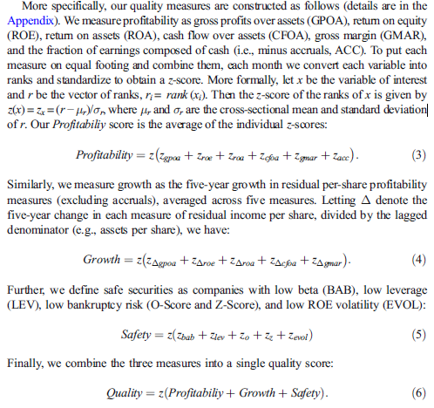

(page 44)

The QMJ factor return is the average return on the two high-quality portfolios minus the average return on the two low-quality (junk) portfolios:

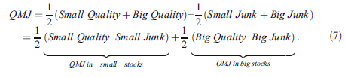

**(page 57? RIGHT AFTER CONCLUSION)**

**Growth**: We compute a growth z-score by averaging z-scores of various measures of

five-year growth in residual profits:

First, we compute growth in residual gross profits over assets … where GP = REVT − COGS and lowercase indicates quantities per share. For example, for any accounting measure X, we let … using the split-adjusted number of shares outstanding S. Similarly, we compute five-year growth in residual

return on equity … five-year growth in residual return over assets … five-year growth in residual

cash flow over assets … and five-year growth in gross margin …

**3.1 Overview**

The signal used for the construction of the primary strategy is the “Quality Minus Junk: Growth” which is the Growth component of “Quality Minus Junk Factor (QMJ)” computed as “QMJ factor return is the average return on the two high-quality portfolios minus the average return on the two low-quality (junk) portfolios” by (insert the paper). More specifically, the theory suggests that the Growth component measure should come from “the increase in sustainable profits in relation to book values”.

The intuition for this measure, as well as for the QMJ factor is that the quality of a company is somehow positively embedded into their price and for that reason investors should be willing to pay a premium to access it. That is, higher quality firms should sport higher prices all else equal. In the case of Growth, “Investors should also pay higher price for stocks with growing profits” (insert citation). That being say, this measure, and the QMJ factor, are price agnostic given they are exclusively based on non-price related fundamental measures (insert Morningstar article <https://www.morningstar.com/articles/746828/the-what-why-and-how-of-quality>) and history has shown that price floats somewhat freely even with high quality stocks. The reason suggested by (insert paper) is that this mispricing is linked behavior finance and other constraints. Effectively, history has shown that investors flee to higher quality stocks during crisis or bear markets thus suggesting an inherent value from holding those companies. With regards to the “QMJ: Growth” signal, past 5 years of growth are often a good signal for a short to long term investment, with this being, in a certain way, a long-term momentum factor. We can perhaps assume that to sustain 5 years of growth across an average of five metrics, it is reasonable to assume this trend will continue, at least in the short term. A characteristic of this measure in relation to the “QMJ: Safety” component is that the former is more adequate for investors with a higher risk desire/tolerance being able to capture high leverage, high beta, high risk and volatility stocks, which, given the small extent prices are explained by quality (around 10% in (insert paper)), can yield larger returns for a smaller risk. **(MISSING A PREVIEW OF THE PERFORMANCE OF THE PRIMARY STRATEGY)**

Therefore, as a stand-alone portfolio, this strategy could perhaps achieve a reasonable balance between return upside and risk, given that the measure is (1) very complete (same as profitability component minus accruals), (2) is observed over a 5 year window, therefore filtering out noise and focusing on sustainable growth and (3) given the current economic outlook, where we are likely to experience a short boom from the pandemic recovery followed by a market correction, this strategy is able to take balanced amounts of risk, not compromising short term potential return upside, while still having solid fundamentals in the event of an economic downturn, albeit significantly more exposed to the technological industry and other high beta, high volatility stocks.

**3.2 Strategy Analysis**

To analyze this indicator, we are going to evaluate portfolio performance using the Arbitrage Pricing Theory of Stephen Ross (1976) – CITAR MELHOR – In essence we want to evaluate how much do the risk-factors of the CAPM and the Fama French 3 Factor Models explain the returns of the indicator’s portfolio. Intuitively, risk factors are portfolios, and their expected excess return is a compensation to investors for bearing the risk of holding these portfolios. Now, when we regress the indicator’s portfolio on these risk factors, we obtain the exposure of the portfolio to that specific risk factor, represented by the coefficients. The intercept of this regression is the (alpha), the risk-adjusted return, that is, the average portfolio return that is not explained by the portfolio’s betas on the risk factors. Intuitively, alpha, if positive, investors are getting a higher return than required by holding that risk. This alpha is then, unrelated to the portfolio’s risk.

Regarding the indicator’s portfolio, on (insert paper) the “QMJ:Growht” is constructed from standard measures of profitability and growth and computed “as the five-year growth in residual per-share profitability measures (excluding accruals), averaged across five measures.” The five-year window is used to reduce noise and focus on sustainable growth. (Insert Formula) (insert correct citation).

Results:

**Cumulative Return of long-only and long-short portfolios – Left Normalized to 10% volatility**

**Table Report**



**–** Discuss these results and what you learn from them. Include a

description of prior work on this topic or related topics, how your findings are similar and how they differ, and your interpretation of

these findings

**3.3 Strategy as part of Diversified Portfolio**

Now we are going to do the Mean-variance portfolio optimization. This is a process of weighting risk, expressed as variance, against expected return and optimize it to find the best trade-off of risk-return. We want to find the tangency portfolio, that is, the portfolio which, being fully invested in risky assets, has the maximum possible sharp ratio. Intuitively the tangency portfolio is the most efficient, generating the most return for every unit of risk taken.

**Performance of long-only and long-short portfolios (Plot)**

**Table report**

**Discuss results**

**–** Discuss these results and what you learn from them. Is your strategy

worth including in a diversified portfolio? How does the relatively

short time period (~20 years) affect your conclusions?